**POLITICAL PARTIES FACT SHEET**

**Republican Party**

The Republican Party is also known as the "Grand Old Party," or GOP. It is a conservative party that favors less government interference, more private enterprise and business, lower taxes, greater personal freedom and a strong foreign policy. They believe lower taxes will promote economic growth and job creation.

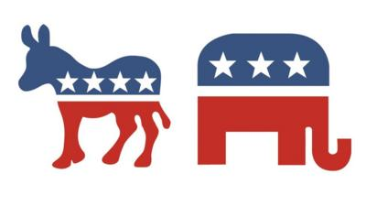

The modern Republican Party supports faith-based initiatives, such as defending marriage as the union between a man and a woman, a strong opposition to abortion, and in some cases, the advocacy of prayer and religious symbols in public schools. The party is against affirmative action, in support of the death penalty, and is more critical of environmental "green" initiatives than the Democrats, arguing that government should limit the amount that it gets involved in the economy. The Republican Party believes that a strong military can best protect the country, and they have appropriated large sums of money for national defense. The GOP voter base includes small business owners, large corporations, families with small children, evangelicals and "born again" Christians, those in the armed services and in general, those earning a higher annual income.

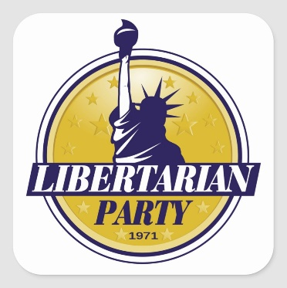**Libertarian Party**

The Libertarian Party is a third party formed in 1971. They are strong advocates of "individual liberties," which they maintain must not be limited by anyone, especially the government. They also believe in a free market economy, and they strive to limit the government as much as possible to the restrictions provided by the U.S. Constitution. For this reason, the party calls for a severe reduction in the size of the federal government, advocating the elimination of some government programs entirely. The Libertarian Party would seek to do away with public health care and many other public services, arguing that private businesses can provide these services better and cheaper, and that no one should be forced to pay taxes to provide government services that are not essential to protecting our liberties.

The party strongly supports the 2nd Amendment (right to bear arms) and opposes limits on gun ownership. They also oppose laws that prohibit or limit personal liberties, such as free speech or drug use. They oppose federal economic regulation entirely, arguing that the government should not get involved in creating rules to limit businesses or protect the environment – if citizens do not like the actions that a business takes, then they will not buy from that business. They also wish to greatly reduce or eliminate federal income taxes, and they support an isolationist foreign policy, reduced taxation, reduced government spending, and the right to carry guns.

**Democratic Party**

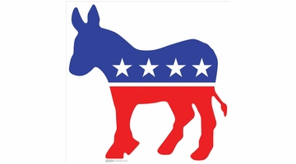The Democratic Party is the largest and oldest party in America. This liberal party generally favors government intervention to promote greater social justice to achieve equality of opportunity. They support government domestic programs and investment in the nation’s infrastructure – such as schools, universities, roads, public works and research. However, paying for these programs would likely result in higher taxes.

The party believes that businesses should be regulated in order to protect workers and protect the environment, and they wish to reform the tax system to benefit the lower classes and the poor. Their voter base includes African Americans, environmentalists, Catholics, Jews, and those with lower annual incomes. Their support spikes in major urban areas. The party supports programs that seek to increase racial and social equality, and many of its members favored the legalization of gay marriages, the abolition of the death penalty, and an economy with some government intervention.

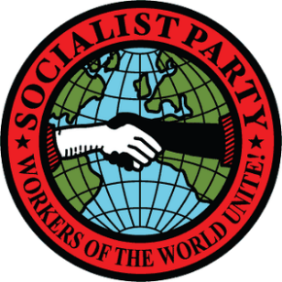**Socialist Party of America**

The Socialist Party of America is a third party founded in 1973. It developed in reaction to the Industrial Revolution, where industrial laborers worked in horrendous conditions for long hours with low pay, while many business owners amassed vast fortunes. Socialists sought to correct these injustices by taking these large businesses away from business owners and by providing large amounts of government services to help out the working class. The Socialist Party desires public (government) ownership of energy, resources, transportation, housing, and other basic industries. The Socialist Party seeks to provide free services to all people in health and education, but taxes would need to greatly increase in order to pay for this.

The party advocates the public ownership of big businesses, which would involve taking the private property of businesses and giving government and workers control over these companies so that they could produce things for the sake of use rather than profit. The party would greatly increase taxes on the wealthy in an attempt to create a classless society, and it would pass many government actions and laws to attempt to stamp out racism, protect the environment, and enforce equality in society, but these laws would come at the expense of individual freedom. It is also strongly committed to feminism and vehemently supports a woman's right to choose (abortion rights).